Enterprise Azure OpenAI Deployment &
Jira Knowledge-Base RAG Agent
Training Guide — From Cloud Foundations to a Production Support Agent
With real-world company use cases and workflow charts

Learning Objectives
After completing this guide, you will be able to:
- Explain the business case for the "RAG + human escalation" pattern and why it dominates enterprise AI deployments
- Describe the end-to-end architecture: Azure OpenAI model deployments, an Azure AI Search vector index, and an n8n agent that answers or escalates to Jira
- Compare Azure OpenAI deployment types (Standard, Global Standard, Data Zone, Provisioned) and plan quota in TPM/RPM terms
- Apply Microsoft’s chunking guidance (~512 tokens, ~25% overlap) and explain vector, semantic, and hybrid retrieval
- Describe how Air India, Vodafone, Siemens, Telstra, Morgan Stanley, and Jobber run this pattern in production, and recognize the workflow shapes behind them
- Apply advanced practices: RAG evaluation, prompt-injection defense, human-in-the-loop approval, cost and quota optimization

1. The Use Case: RAG + Human Escalation

1.1 The Business Problem
Every organization accumulates internal knowledge — IT runbooks, HR policies, product documentation, troubleshooting guides — scattered across wikis, PDFs, and people’s heads. Employees lose time hunting for answers, and support teams spend much of their day re-answering routine questions (password resets, access requests, how-to questions) that documentation already covers.
A general-purpose chatbot cannot fix this: a public LLM has never seen the company’s internal documents, and asked about them it will either refuse or fabricate. The fix is Retrieval-Augmented Generation (RAG) — in Microsoft’s words, "a pattern that extends LLM capabilities by grounding responses in your proprietary content."

1.2 The Five RAG Challenges
Microsoft’s Azure AI Search documentation identifies five challenges every RAG implementation must solve. Each later section of this guide addresses one or more of them:
Challenge | What it means for this system
Query understanding | Users ask vague, conversational questions ("wifi keeps dropping") that don’t match document wording ("wireless connectivity troubleshooting"). Retrieval must match intent, not keywords.
Multi-source data access | Knowledge lives in many places; the index must unify it without disrupting where documents normally live.
Token constraints | LLMs accept limited input. Retrieval must return a few highly relevant chunks, not entire manuals.
Response time | Employees expect answers in seconds; retrieval plus generation must stay fast.
Security and governance | Users must only be able to retrieve content they are authorized to see.
Source: Microsoft Learn, "Retrieval-augmented generation (RAG) in Azure AI Search."

1.3 Why Escalation Makes It Trustworthy
No knowledge base is complete. A well-designed support agent must recognize when it cannot answer and hand off to a human rather than fabricate — wrong answers erode trust faster than slow answers ever did. Automatically opening a Jira ticket with the original question and conversation context turns a dead end into a tracked, actionable item. Every production deployment profiled in Section 6 follows this same split: answer what the knowledge base supports, hand off what it doesn’t.

2. Architecture: One Agent, Two Azure Services, One Ticket Queue
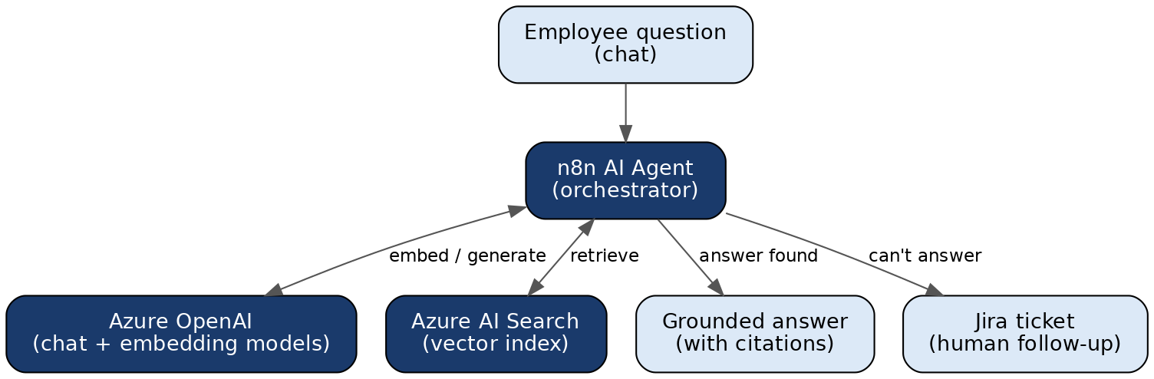
Figure 1 — End-to-end system: the n8n agent orchestrates Azure OpenAI and Azure AI Search, then answers or escalates to Jira

2.1 Azure Foundations
Azure AI Foundry is Microsoft’s unified portal for building, deploying, and monitoring AI models and agents. It sits on top of the same resources you would manage in the classic Azure Portal, organized around AI-specific workflows: model catalogs, deployments, evaluation, and agent orchestration.
A Resource Group is a logical container holding related resources — here, one Azure OpenAI resource and one AI Search service. Enterprises organize around Resource Groups to:
- Apply access control (RBAC) to a whole project at once, rather than resource-by-resource
- Track and allocate cost per project, team, or environment (dev / staging / production)
- Delete an entire environment in one action — useful for temporary or test environments

2.2 Network & Identity Security
In a learning environment, resources are typically left open to the public internet for simplicity. A production deployment adds several layers:
Control | What it does
Private Endpoint | Routes traffic through the Azure virtual network instead of the public internet
Network Security Group / Firewall rule | Restricts which IP ranges or virtual networks can reach the resource
Managed Identity | Lets one Azure resource authenticate to another without storing a secret/API key anywhere
RBAC role assignment | Grants a specific identity only the minimum permission it needs (e.g., Cognitive Services OpenAI User)
Source: Microsoft Learn, Azure AI Search security overview and Azure OpenAI documentation.
This guide connects n8n to Azure with API keys — the fastest path. In production, prefer Managed Identity wherever the calling service also runs inside Azure.

3. Model Deployments

3.1 Two Different Models, Two Different Jobs
Model type | Job in this system | Example
Chat / completion model (LLM) | Reads the retrieved documents and the user’s question, writes a natural-language answer | gpt-5o-mini
Embedding model | Converts text into numeric vectors that can be compared for similarity | text-embedding-3-small

These are deployed as separate "deployments" under the same Azure OpenAI resource, each with its own name, quota, and version — so you can upgrade or swap one without touching the other. The chat model is optimized for reasoning and writing; the embedding model for representing meaning as a vector so that similar meanings land mathematically close together. A RAG system almost always needs both.

3.2 Deployment Types and Quota
Quota is assigned per subscription, per region, per model, in Tokens-per-Minute (TPM), with requests-per-minute (RPM) limits alongside. Choosing a deployment type is a real architectural decision:
Deployment type | Characteristics | Typical use
Standard | Pay-per-token, processed within the resource’s region | Data-residency-sensitive workloads
Global Standard | Pay-per-token, routed across Azure’s global infrastructure; highest default quota | Default starting point for most workloads
Data Zone Standard | Pay-per-token, processing kept within a defined data zone (e.g., EU) | Regional compliance requirements
Provisioned (PTU) | Reserved capacity for predictable throughput and latency | High-volume production systems
Source: Microsoft Learn, "Understanding deployment types" and "Azure OpenAI quotas and limits."

3.3 Connecting to n8n
Once a model is deployed, n8n needs four pieces of information to call it:
- Endpoint URL — which Azure region/resource to call
- API Key — authentication
- Deployment name — which specific model deployment to use
- API version — which version of the Azure OpenAI REST API to speak

4. The Knowledge Base: Azure AI Search

4.1 Chunking
Large documents must be split before embedding — embedding models have maximum input sizes, and retrieval works better on focused passages. Microsoft’s guidance for Azure AI Search:
- Start with a chunk size of about 512 tokens (roughly 2,000 characters)
- Use about 25% overlap (~128 tokens) between consecutive chunks so context isn’t cut mid-thought
- Adjust by content type: structured data needs less overlap; narrative text may benefit from more
- Azure AI Search can also chunk automatically at indexing time via the built-in Text Split skill (integrated vectorization); in this system the n8n ingestion workflow does the chunking — same concept, different place
Source: Microsoft Learn, "Chunk documents for vector search solutions."
Figure 2 — The indexing pipeline: upload → chunk → embed → store in the vector index

4.2 Vector, Semantic, and Hybrid Retrieval
 | Vector Search | Semantic Ranking (re-ranking)
What it compares | Numeric closeness between embeddings | Deep language understanding of the actual query and passage text
Strength | Fast, scales to millions of documents | Improves the ordering of top results using contextual understanding
Typical use | First-pass retrieval — "the 20 most relevant chunks" | Re-ranking — "of those 20, which 3 actually answer the question"

Microsoft recommends going one step further: hybrid queries run the same input as a keyword query and a vector query in parallel and merge the results. Keyword search catches exact terms (error codes, product names) that pure vector search can miss; hybrid + semantic ranking is the recommended classic-RAG retrieval stack.
Source: Microsoft Learn, "Hybrid search" and "Semantic ranking in Azure AI Search."

4.3 Index Schema Basics
Every document in the index typically has at least: an id (unique chunk identifier), content (the original chunk text), contentVector (the embedding, stored as a vector field), and metadata fields such as source filename, upload date, and category.

5. The Agent: n8n Orchestration and Jira Escalation

5.1 Inside the n8n AI Agent Node
In n8n’s architecture, the AI Agent node is a root node that works as a Tools Agent, implementing LangChain’s tool-calling interface. Capabilities plug in as typed sub-connections:
- Chat Model — the LLM doing the reasoning (here: the Azure OpenAI chat deployment)
- Memory — conversation history so follow-ups keep context; per n8n’s docs, memory does not persist between sessions unless you configure external storage
- Tools — the actions the agent may take; each tool’s name and description tell the LLM when to use it. Here: knowledge-base search (Azure AI Search), optional directory lookup (Microsoft Entra ID), and ticket creation (Jira)
Source: n8n Docs, "AI Agent node" and "LangChain in n8n."

5.2 The Answer-or-Escalate Decision
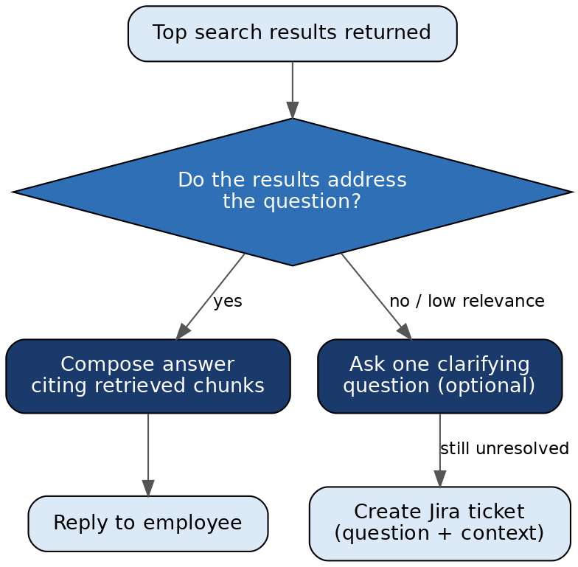
Figure 3 — The agent’s decision logic: answer from retrieved chunks, or create a Jira ticket with full context
The threshold for "the results address the question" lives in the agent’s system prompt — a design decision, not a fixed rule. Stricter means more tickets but fewer wrong answers; looser means fewer tickets but higher hallucination risk.

5.3 What Gets Sent to Jira
- Ticket summary — a short auto-generated title
- Description — the original question plus relevant conversation context
- Project and issue type — chosen from the project key configured in n8n
- (Optional) Priority or labels, if the agent is prompted to classify severity

5.4 The Escalation Loop Closes the Knowledge Gap
Figure 4 — Every escalated ticket is a signal about which document to write next

6. Real-World Company Use Cases
The cases below are published customer stories from Microsoft, OpenAI, and Atlassian’s ecosystem. Each maps to a workflow pattern you can reproduce with the building blocks in this guide.

6.1 Air India — AI.g, RAG-Grounded Passenger Support
Air India built AI.g, a generative AI virtual assistant on Azure OpenAI Service, with Azure AI Search providing RAG grounding and Azure Cosmos DB storing conversations, user states, and vectors. Per Microsoft’s customer story, AI.g handles tens of thousands of daily queries about bookings and flight status, automating roughly 97% of interactions and freeing human agents for complex cases.
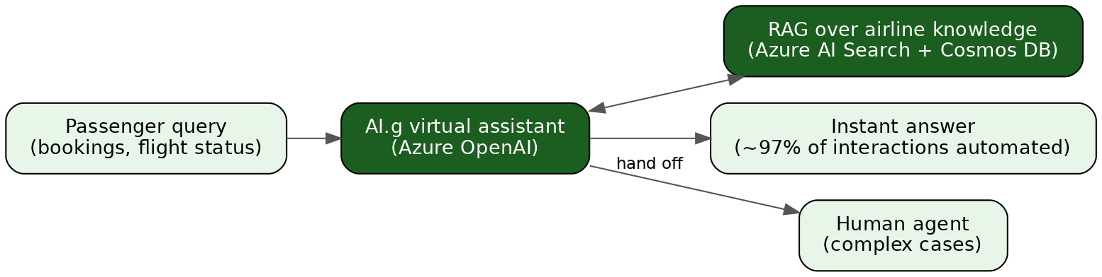
Figure 5 — Air India’s AI.g: RAG-grounded answers, human hand-off for the rest
- Pattern to notice: the same answer-or-hand-off split as this guide’s agent — automation rate is the headline metric.

6.2 Vodafone — SuperTOBi and SuperAgent
Vodafone’s virtual assistant TOBi (now SuperTOBi, rebuilt on Azure OpenAI and rolled out across multiple countries) answers customer questions in natural language. When it cannot resolve an issue, it transfers the customer to a human agent along with a summary of the conversation so the agent can jump straight in. On the agent’s side, SuperAgent — built on Azure OpenAI with Azure AI Search — retrieves answers from Vodafone’s knowledge base, and call summaries are stored in the CRM.
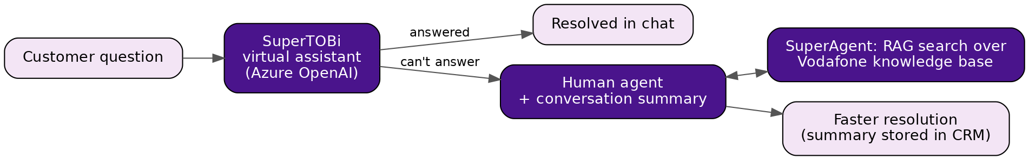
Figure 6 — Vodafone: escalation with context — the hand-off carries a conversation summary, and the human gets their own RAG tool
- Pattern to notice: escalation done well transfers context, not just the customer. This guide’s Jira ticket carrying question + conversation context is the same idea.

6.3 Siemens — Voice-to-Ticket on the Factory Floor
Siemens’ Teamcenter for Microsoft Teams app, powered by Azure OpenAI, lets shop-floor workers report product design or quality problems by speaking naturally — in their own language, gloves on. Azure OpenAI parses the informal speech, automatically creates a summarized problem report, and routes it within Teamcenter to the appropriate design, engineering, or manufacturing expert. Problems that previously went unreported because reporting was too hard now enter the tracked workflow.
Figure 7 — Siemens: natural speech in, routed and tracked problem report out — ticket creation as the product
- Pattern to notice: this is the escalation half of this guide’s system standing alone — LLM-drafted, automatically routed tickets have production value even without the Q&A half.

6.4 More Examples in Brief
- Telstra — Ask Telstra combines Azure OpenAI with Azure AI Search over the internal knowledge base; 84% of customer service agents said it positively affected customer interactions, and its companion summarization tool cut follow-up contact by ~20%.
- Morgan Stanley — the AI @ Morgan Stanley Assistant retrieves from ~100,000 internal research documents and answers exclusively from internal content; over 98% of advisor teams use it — RAG at large scale in a heavily regulated industry.
- Jobber — connected an AI support agent to Slack, Jira Service Management, and Confluence; routine IT questions answered from documentation, the rest escalated as Jira tickets — 38% IT ticket automation reported. Atlassian’s own Rovo service agents follow the same shape.

6.5 What These Cases Have in Common
Pattern | Example company | Building block in this guide
Grounded Q&A over enterprise knowledge (RAG) | Air India, Telstra, Morgan Stanley | Azure AI Search index + chat model (Sections 3–4)
Escalation that carries context to a human | Vodafone, Jobber | Jira ticket with question + conversation context (Section 5)
LLM-drafted, auto-routed tickets | Siemens | The Jira tool call itself (Section 5.3)
Automation rate as the success metric | Air India (97%), Jobber (38%) | Escalation-rate monitoring (Section 7.4)
Sources: Microsoft Customer Stories (Air India, Vodafone, Siemens, Telstra); OpenAI (Morgan Stanley); Atlassian blog and Risotto case study (Jobber). URLs in the Appendix.

7. Advanced Usage

7.1 Evaluating RAG Quality
"It sounds right" is not a quality bar. Production teams maintain a golden set of question–answer pairs and score the system against it whenever the index, prompt, or model changes. The two metrics that matter most:
- Groundedness — is every claim in the answer supported by the retrieved chunks? Ungrounded claims are hallucinations even when factually correct.
- Retrieval relevance — did the right chunks come back at all? If not, the failure is in chunking, embeddings, or query construction — no prompt fix will save it.
Azure AI Foundry ships built-in evaluators (groundedness, relevance, and others) that can run LLM-scored evaluations over test sets — worth adopting before scaling beyond a pilot.
Source: Microsoft Learn, "Evaluation of generative AI applications" (Azure AI Foundry).

7.2 Advanced Retrieval
- Query rewriting — have the LLM rewrite conversational input ("it’s still broken") into a self-contained search query using conversation history, before retrieval.
- Thresholds and top-k tuning — cap how many chunks reach the LLM and set minimum similarity scores; more context is not better context.
- Scoring profiles — boost authoritative or recent documents over stale ones at ranking time.
- Agentic retrieval (preview) — Azure AI Search can now let an LLM plan retrieval itself: decompose a complex question into parallel subqueries and return structured, citation-ready results. Microsoft positions classic RAG for simplicity and GA features; agentic retrieval for new agent builds needing maximum relevance on conversational queries.
Source: Microsoft Learn, "Retrieval-augmented generation in Azure AI Search" — agentic retrieval and relevance sections.

7.3 Security Hardening
- Prompt injection — indexed documents become part of the prompt; a malicious document can carry instructions ("ignore previous rules and…"). Azure AI Content Safety’s Prompt Shields detect such attacks in user input and documents.
- Content filtering — Azure OpenAI applies configurable content filters on input and output by default; Air India additionally used Azure AI Content Safety for harmful-content mitigation.
- Security trimming — Azure AI Search supports document-level filtering at query time so users only retrieve what they’re authorized to see; AI Search can inherit Microsoft Entra ID permission metadata for some sources.
Source: Microsoft Learn, "Prompt Shields in Azure AI Content Safety" and "Security filters for trimming results."

7.4 Operating at Scale
- Monitoring — log every question, the retrieved chunks, and the final answer (audit trail); track escalation rate — a sudden rise usually means stale documentation or an indexing failure; collect thumbs-up/down in the chat channel.
- n8n operations — add an error workflow for failed executions, split ingestion and chat into separate workflows, and use queue mode (multiple workers) for high-volume production loads.
- Human-in-the-loop — for sensitive actions (account changes, purchases), insert an approval step before the agent’s action executes, keeping the judgment call with a person — the split Gallagher and Fujitsu use in production.
- Cost and quota — retrieved chunks are input tokens, so retrieval size directly drives LLM cost; consider routing easy questions to a smaller model first; plan TPM quota before rollout — a pilot serving 50 employees can rate-limit at 5,000.
Source: n8n Docs (error workflows, queue mode); Microsoft Learn (quotas and limits).

7.5 Data Governance
Decide what must never enter the index: credentials, personal data, unreleased financials, security procedures. An index is only as safe as its least-appropriate document — the agent will happily quote anything it retrieves.

8. Connecting This Back to the Hands-On Build
Everything in the hands-on project — a chat model deployment, an embedding deployment, an Azure AI Search index, and an n8n agent with a Jira tool — is a hand-built version of the pattern the companies in Section 6 run in production:
- The n8n AI Agent plays the orchestration role that Air India and Vodafone build into their assistant platforms — deciding when to retrieve, when to answer, when to hand off
- The Jira tool call is the same "escalation with context" that Vodafone’s human hand-off and Siemens’ auto-routed problem reports implement at scale
- The chunk-embed-index pipeline is the manual version of what Azure’s integrated vectorization and agentic retrieval now package as managed features — understanding the manual version is what makes the managed shortcuts legible

9. Review Questions

IT Helpdesk vs. Medical-Advice Bot Escalation Thresholds
Suggested Answer: IT helpdesks typically set a looser threshold to maximize self-service and reduce agent load, as the risk of a slightly wrong password-reset instruction is low. Medical-advice bots require an extremely strict threshold (or a mandatory human-in-the-loop); the risk of a hallucinated medical recommendation is too high for pure automation.

Explaining the Automation Gap: Air India vs. Jobber

Suggested Answer: The gap likely stems from domain complexity. Air India deals with structured, repetitive tasks (flight status, bookings) where a RAG system can be highly accurate. Jobber (IT support) handles a wider variety of troubleshooting scenarios across different software, which often requires human intuition or physical access. The "right" target depends on the point where automation no longer provides a safe or helpful user experience.

Risks of LLM-Summarized Escalation Context
Suggested Answer: The primary risk is "hallucinated brevity," where the LLM omits a critical detail (e.g., an error code mentioned by the user) because it deemed it less relevant for the summary. This can lead to the human agent repeating questions the user already answered, frustrating the customer. Providing the full transcript as a secondary reference is the best mitigation.

Deployment Selection for 10,000-Employee Rollouts
Suggested Answer: Global Standard is the logical starting point due to its high default quota and cost-efficiency. A switch to Provisioned (PTU) would be necessary if the organization requires guaranteed latency for a high-priority real-time application or if the usage volume reaches a point where PTU pricing becomes more cost-effective than pay-per-token.

Diagnosing a Doubled Escalation Rate
Suggested Answer: Three causes: 1) Stale documentation (check if questions refer to a recent software update), 2) Indexing failure (check for 0-result vector searches in logs), and 3) A change in user behavior (check if a new department was onboarded). You can distinguish these by comparing the ratio of "no chunks found" vs. "chunks found but didn't answer" in the system logs.

Privacy-Centric Data Exclusion
Suggested Answer: One would exclude PII (Social Security numbers, personal addresses), internal passwords, and unreleased strategic plans. While including these might help the agent resolve specific account or strategy queries, the risk of the agent leaking that information to unauthorized users via a clever prompt outweighs the utility.

Appendix — Reference Links

Official Documentation
- RAG in Azure AI Search — learn.microsoft.com/azure/search/retrieval-augmented-generation-overview
- Chunk documents for vector search — learn.microsoft.com/azure/search/vector-search-how-to-chunk-documents
- Hybrid search — learn.microsoft.com/azure/search/hybrid-search-overview
- Azure OpenAI quotas and limits — learn.microsoft.com/azure/foundry/openai/quotas-limits
- Deployment types — learn.microsoft.com/azure/foundry/foundry-models/concepts/deployment-types
- n8n AI Agent node — docs.n8n.io/integrations/builtin/cluster-nodes/root-nodes/n8n-nodes-langchain.agent
- LangChain in n8n — docs.n8n.io/advanced-ai/langchain/overview

Company Case Studies
- Air India — microsoft.com/en/customers/story/26047-air-india-azure-openai-in-foundry-models
- Vodafone — microsoft.com/en/customers/story/1770174778560829849-vodafone-group-azure-telecommunications-en-united-kingdom
- Siemens — microsoft.com/en/customers/story/1703499442875711080-siemens-digital-industries-software-microsoft-azure-ai-germany
- Telstra — microsoft.com/en/customers/story/1740058425924206437-telstra-telecommunications-azure-openai-service
- Morgan Stanley — openai.com/index/morgan-stanley
- Jobber / Rovo pattern — atlassian.com/blog/jira-service-management/rovo-agents-service-desk-instant-resolution; tryrisotto.com/blog/ai-it-support
Note: URLs current as of July 2026. Azure documentation updates on a roughly 90-day cycle — verify terminology against "What’s new" pages when in doubt.

